**How to Calibrate the Touch Screen**

1. **Install Xinput**

cd /boot

cd LCD-show

sudo dpkg -i -B xinput-calibrator_0.7.5-1_armhf.deb

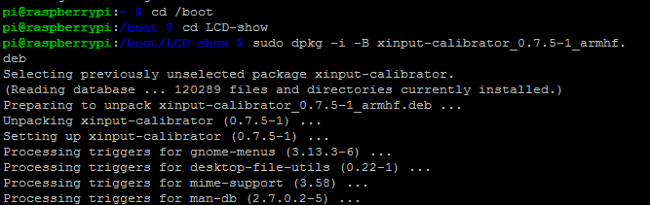

**2、****Execute touch calibration commands:**

DISPLAY=:0.0 xinput_calibrator

Then the screen will pop up to touch the calibration interface, you should click one by one with the touch pen on the four calibration points to complete the calibration.

After the calibration is completed, the new touch parameters will be displayed, as pictured

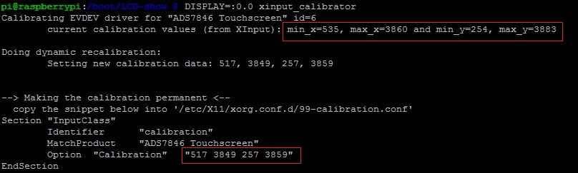

**3、Modify and Save the calibration of Touch parameter**

sudo nano /etc/X11/xorg.conf.d/99-calibration.conf

As pictured:

